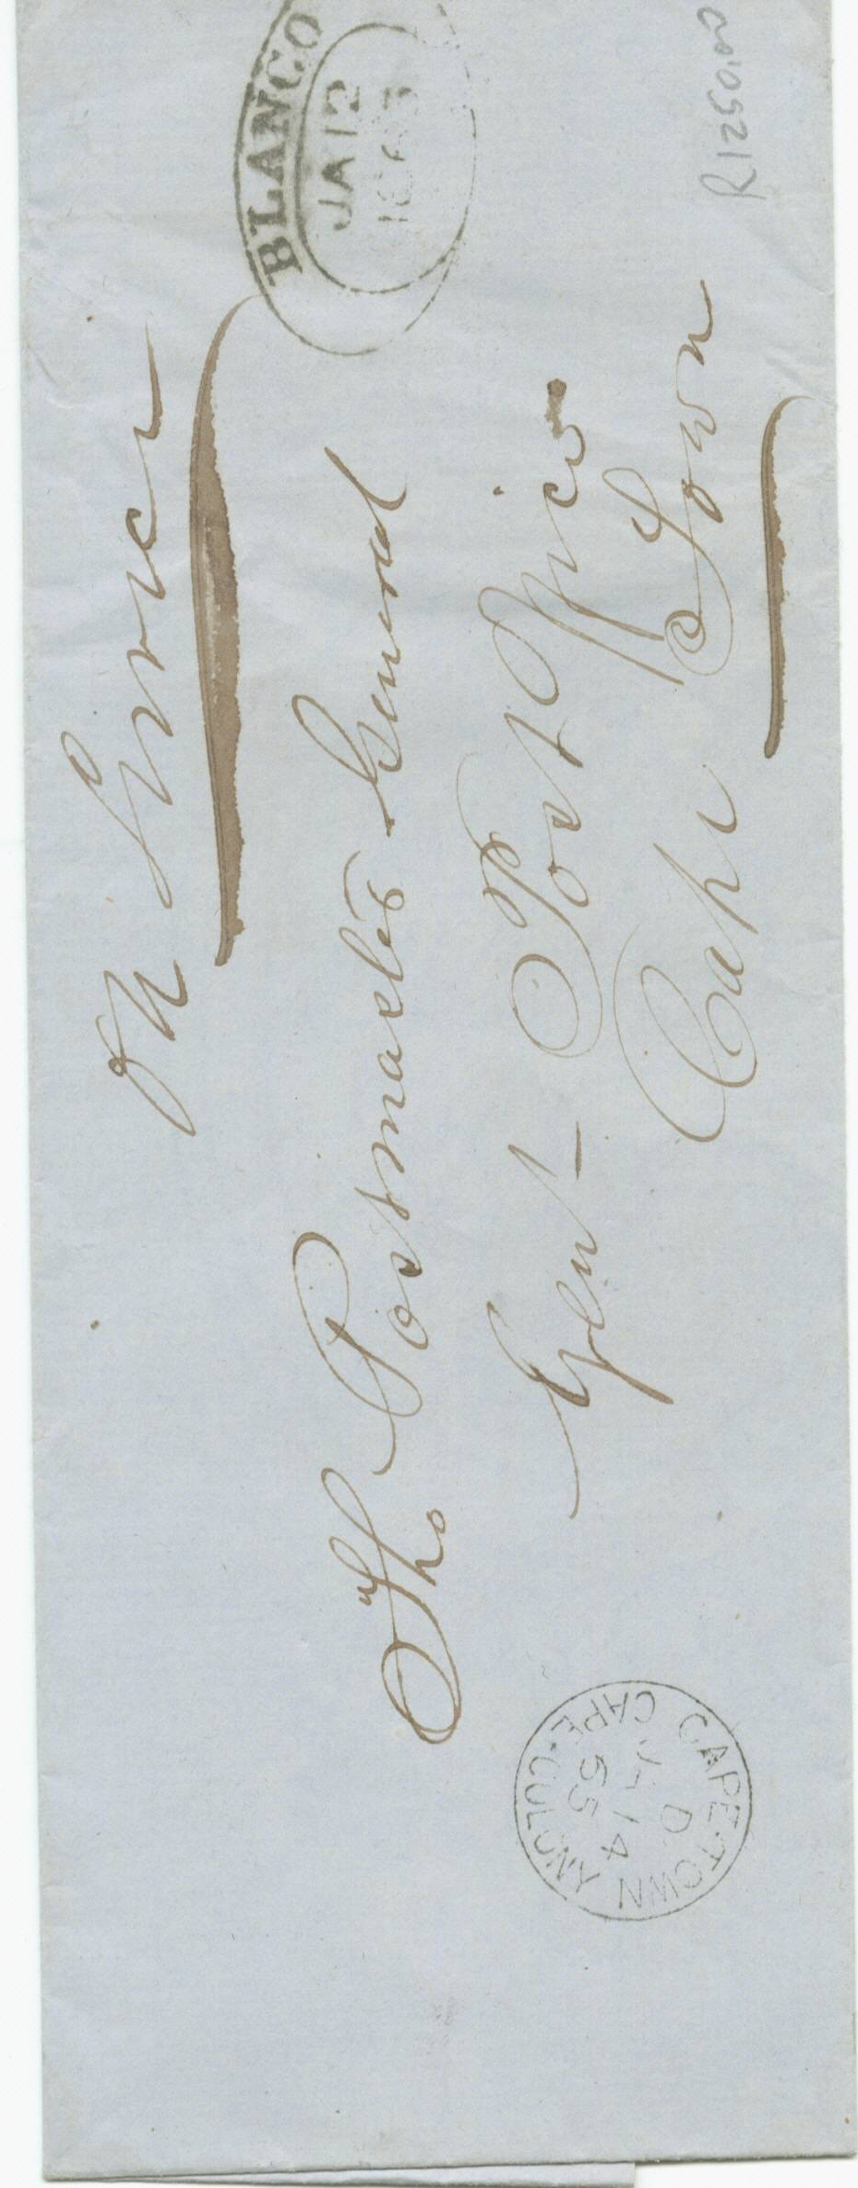
+

BLANCO TOWN OVAL HANDSTAMP

1865 on H M Service pale blue outer letter sheet, from the Blanco post office showing a fine black strike of the “Blanco D.T.O.” of 12th January 1863. Cape Town receiving cds on front dated “JA 14 65”.

CAPE OF GOOD HOPE

DEVELOPENT OF POSTAL SERVICES

The Dated Town Oval

Handstamps of 1853

